**Lab Operators (Day-2)**

1. **Calculate the multiplication and sum of two numbers.**

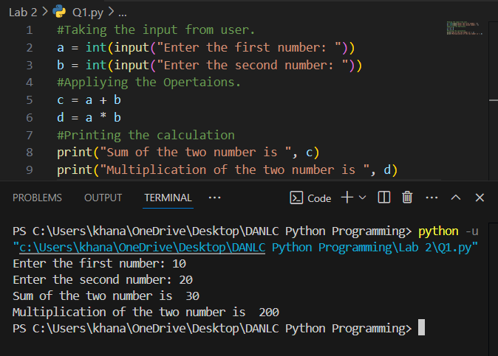

1. **Declare two variables & print that which variable is largest using ternary operators.**

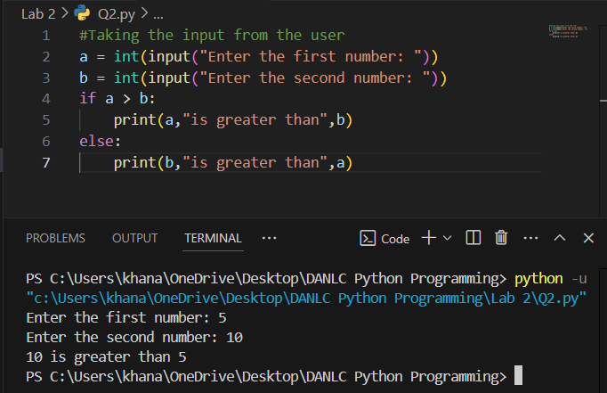

1. **Python program to convert the temperature in degree centigrade to Fahrenheit.**

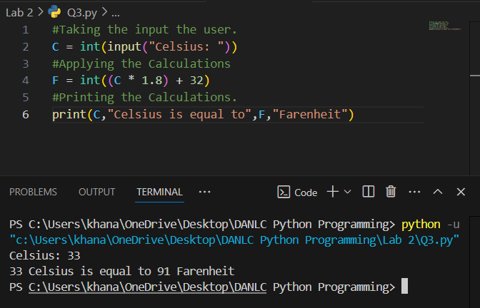

1. **Python program to find the area of a triangle whose sides are given.**

